Day 5 – 30th May 2025 - 113195064 – Bondili Bhavya Charitha

**TASK:1 - Create a Directory with the Name Linux Practice.**

mkdir linuxpractice

**TASK:2 - Change to the directory**

cd.\LinuxPractice\

**TASK:3 - Create a file name TestFile1.txt and add the content to it**

touch testfile1.txt

**TASK:4&5 - Create a Folder named Dummy and try to delete it, check the working directory.**

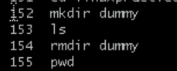

**TASK:6 - How do you check all the files and directories in the directory you are in?**

Ls

**TASK:7 - Create five files named TestFile2.txt. TestFile3.txt… and so on till TestFile6.txt**



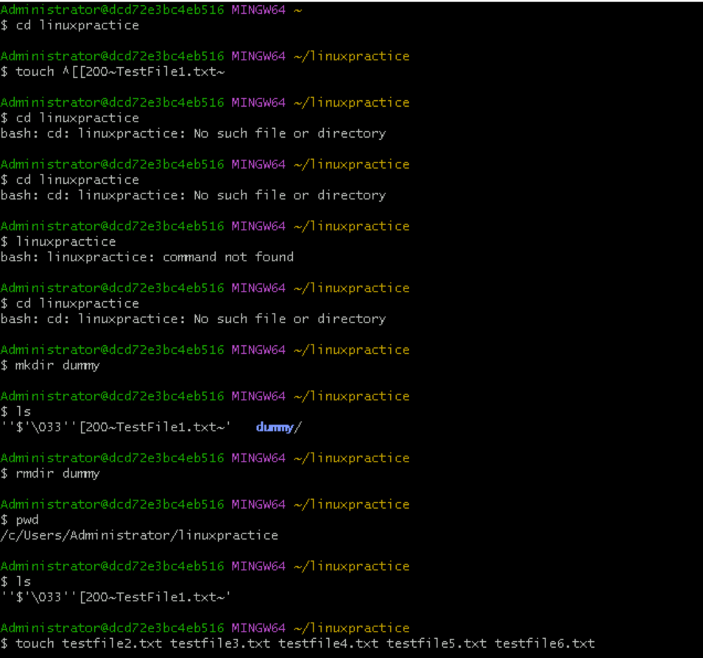

**TASK:8 & 9 – Copy all files from DIR 1 to DIR 2, Move all files from DIR 2 to DIR 3.**

cp 1sttest/* 2ndtest/

mv 2ndtest/* 3rdtest/

**TASK:10 - Can you plz show me the diff between rm and rmdir commands?**

rm testfile1.txt – deletes file

rm -r 1sttest – deletes the directory and its contents.

**TASK:11 - Create a file and add the dummy text of 2 to 3 paragraphs from the above link Lorem Ipsum.**

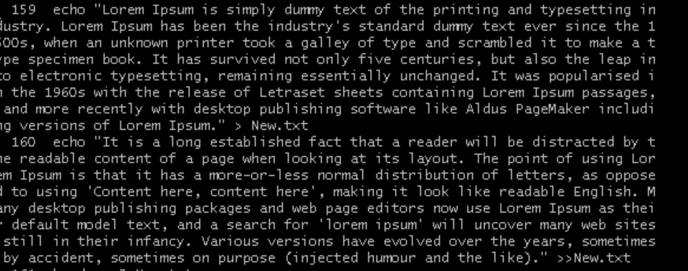

**TASK:12&13 - How to get only the top part of your file and how to get only the last part of your file?**

head -n 3 New.txt

tail -n 3 New.txt

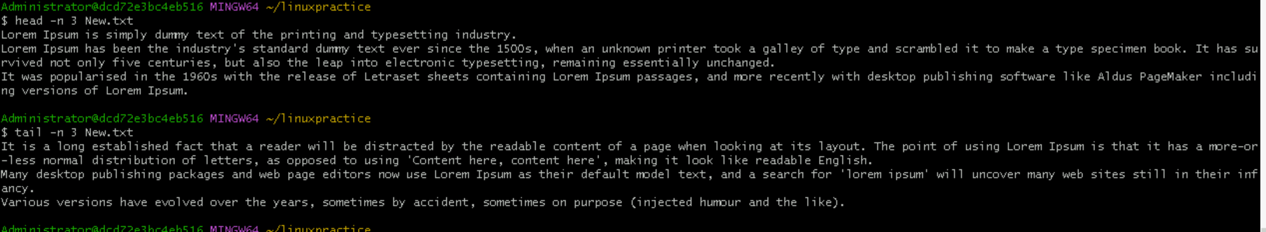

**TASK:14 – Add dummy text of 3 pages to the same file. Show the file in page by page.**

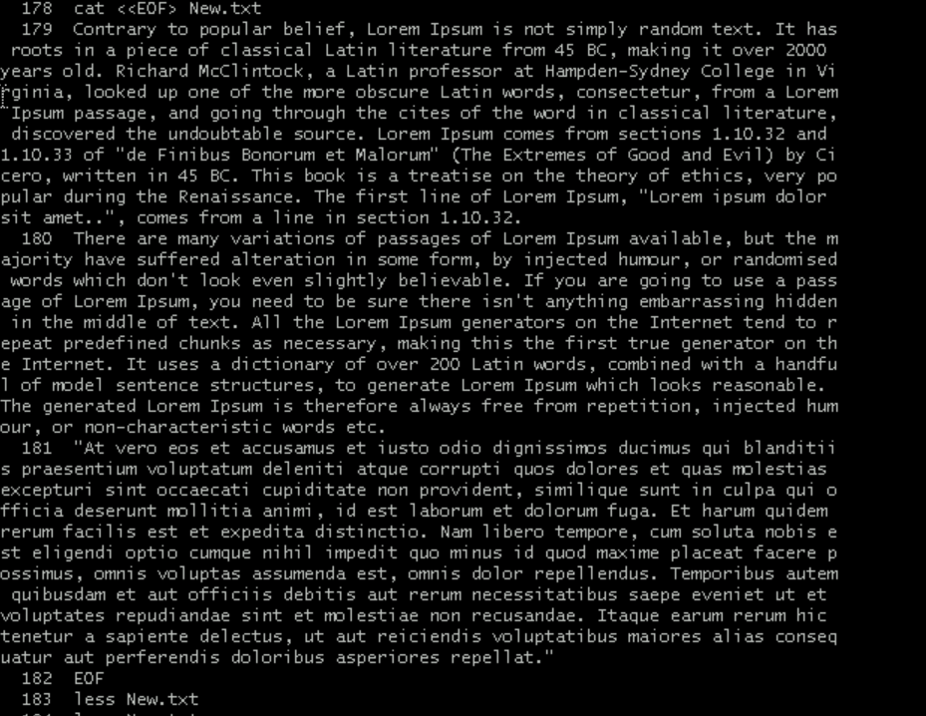

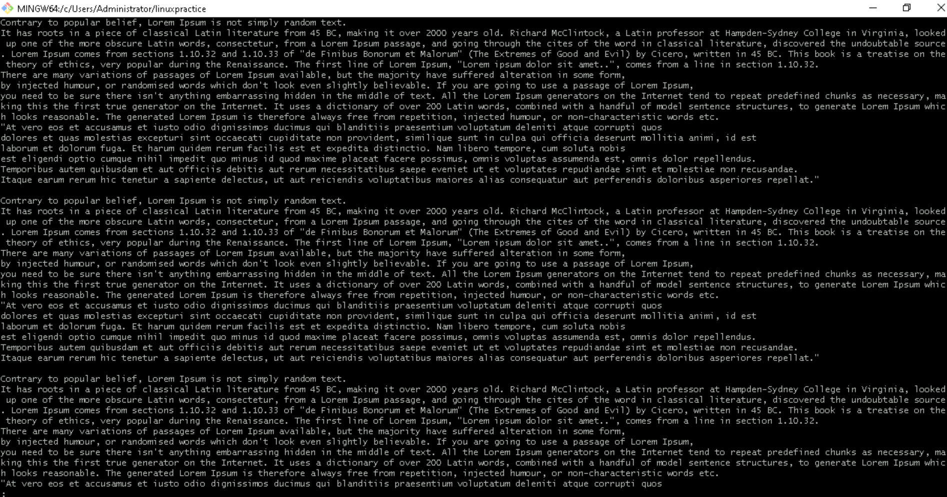

**TASK:15 - Use more command on the above file.**

More command didn’t work in bash, shell, ubuntu and cmd.

**TASK:16 - Can you use echo command with -e.**

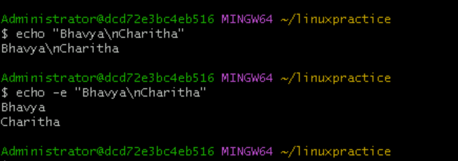

**TASK:17 – What is between ls and ls -l command (SS)**

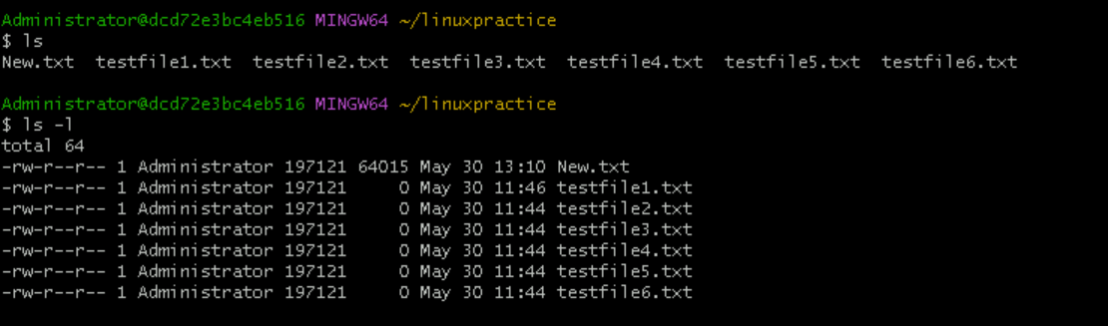

**TASK:18 - Create a file using touch command, cat command and echo command and take ss (screen shot).**

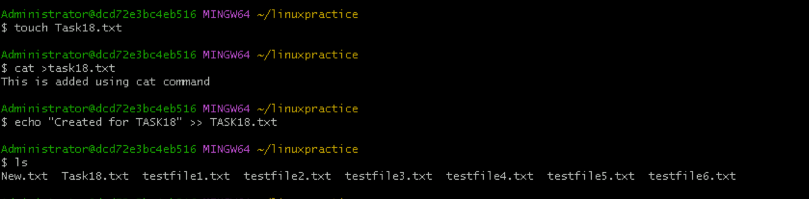

**TASK:19 – Display the calendar by using a command**

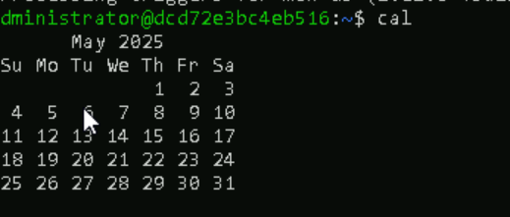

Ubuntu….

**Task: 20 - Can you go back to 1 directory. at a time, what’s the command**

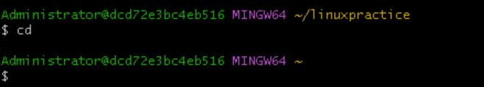

**TASK: 21- How to know whose user u are working on?**

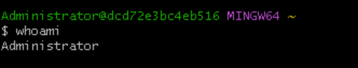

**TASK: 22 - Try to find out who is peeping into your system.**

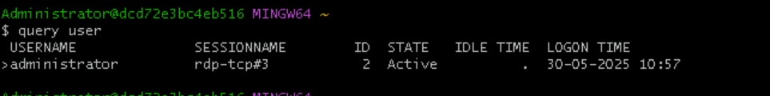

**TASK: 23 - Can you guys try to check how much disk space is consumed.**

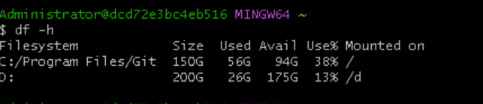

**TASK :24 – Trying commands**

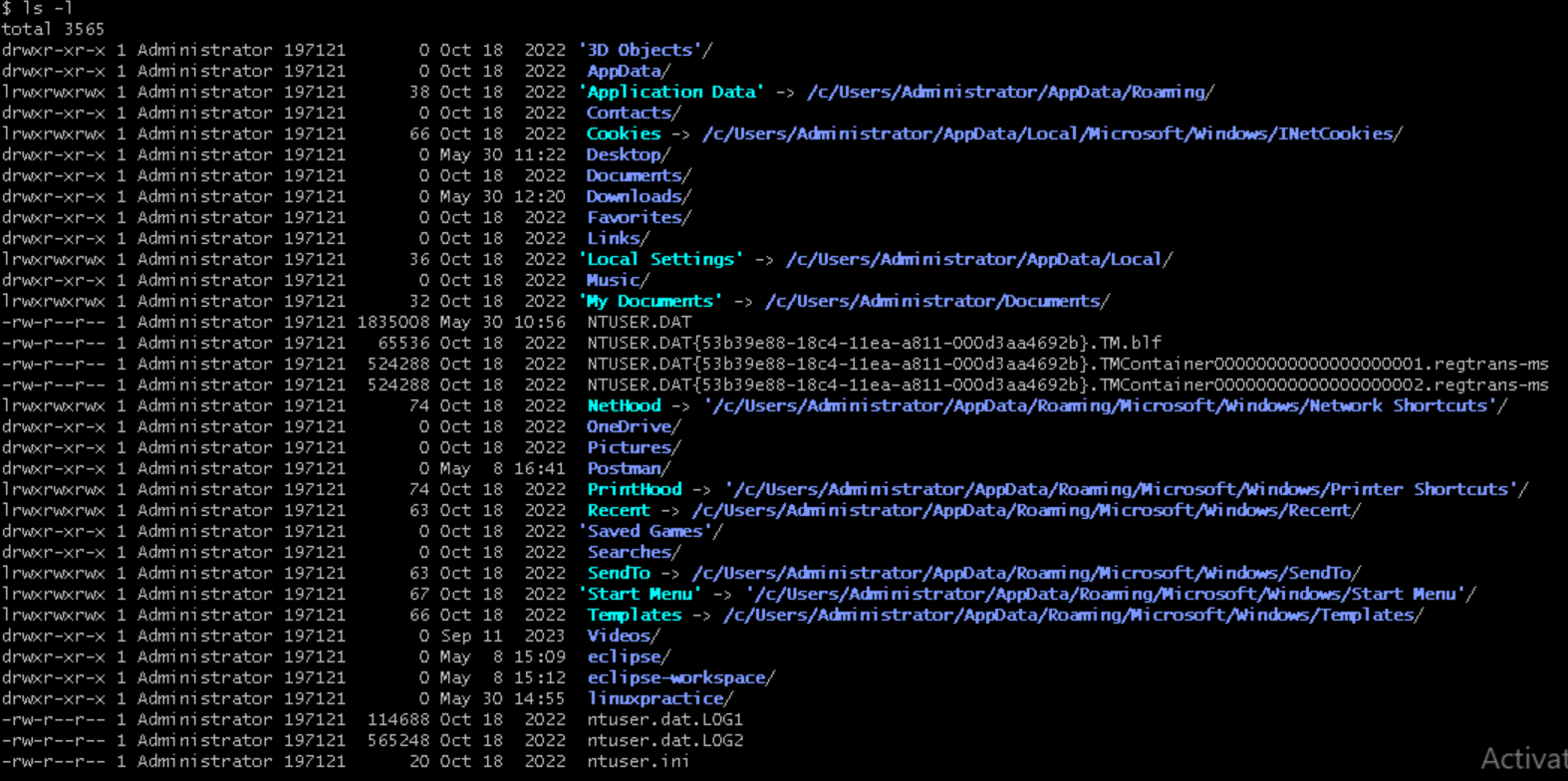

**TASK: 25 - Find the list pf all files ending with .txt**



**TASK:26 – How to check all the hidden files in linux**

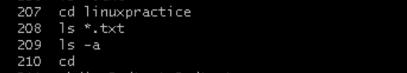

**TASK:27 – DONE ORAL**

**TASK: 28 - Can you create a file using vi editor and show the details in ss**

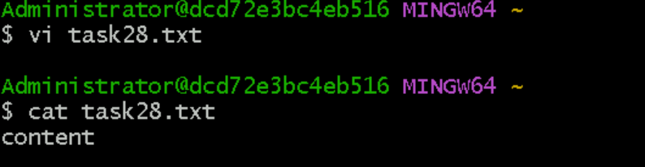

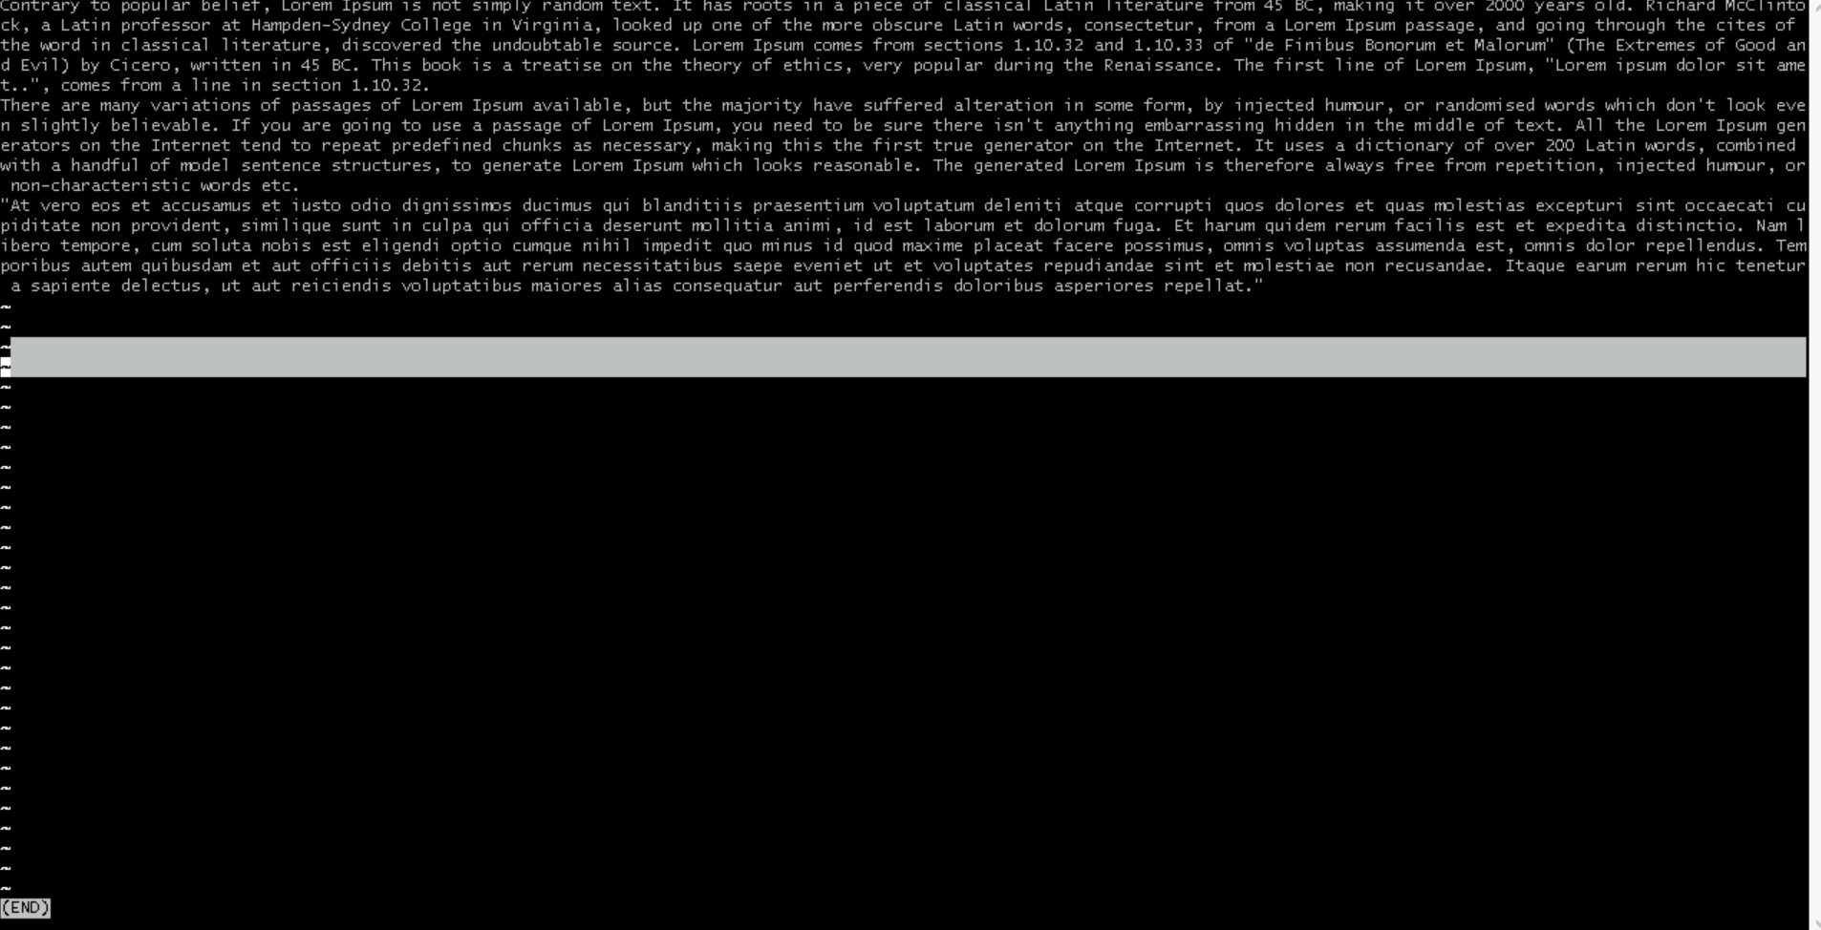

**TASK: 29 - How to find the no of words in the file?**



**TASK:30 – DONE ORAL**

**TASK: 31 - Can I use the wc with 2 or more files?**

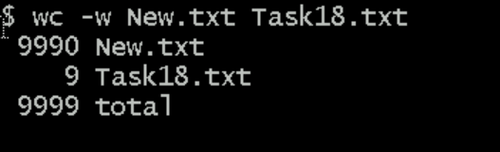

**TASK: 32 - How to copy content of one file to another file?**



**TASK: 33- Now I want to rename my file with MYFILENEW can i do that if so how?**

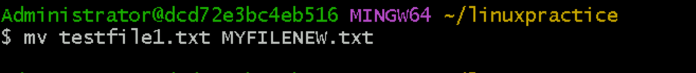

**TASK: 34 - Can i remove or delete multiple files in linux?**

YES we can do – rm New.txt Task18.txt

**TASK:35 - In directory / slash is root. can you try cd / what is it doing?**

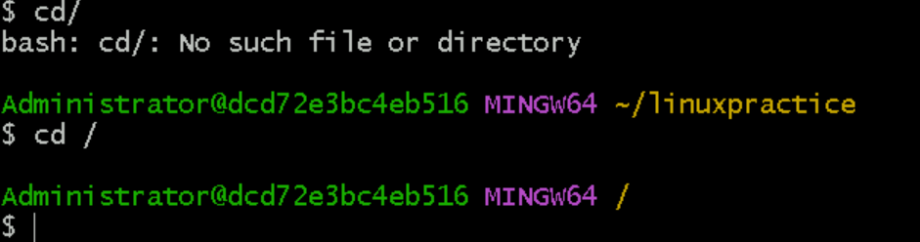

**TASK: 36 - What is the way go to home directory?**

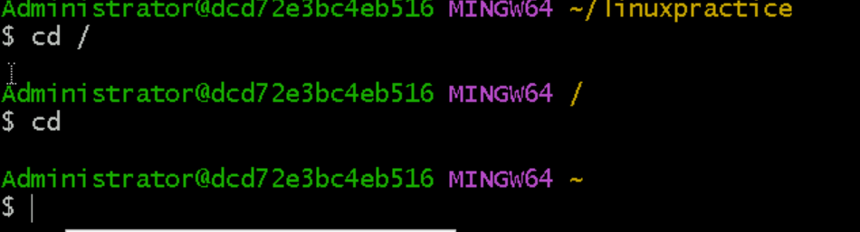

**TASK: 37 - If i want to move to different user’s home directory**

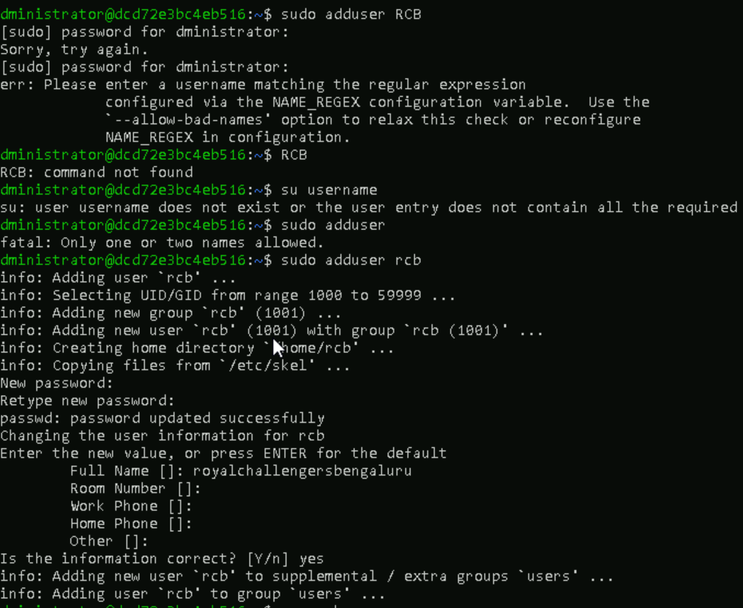

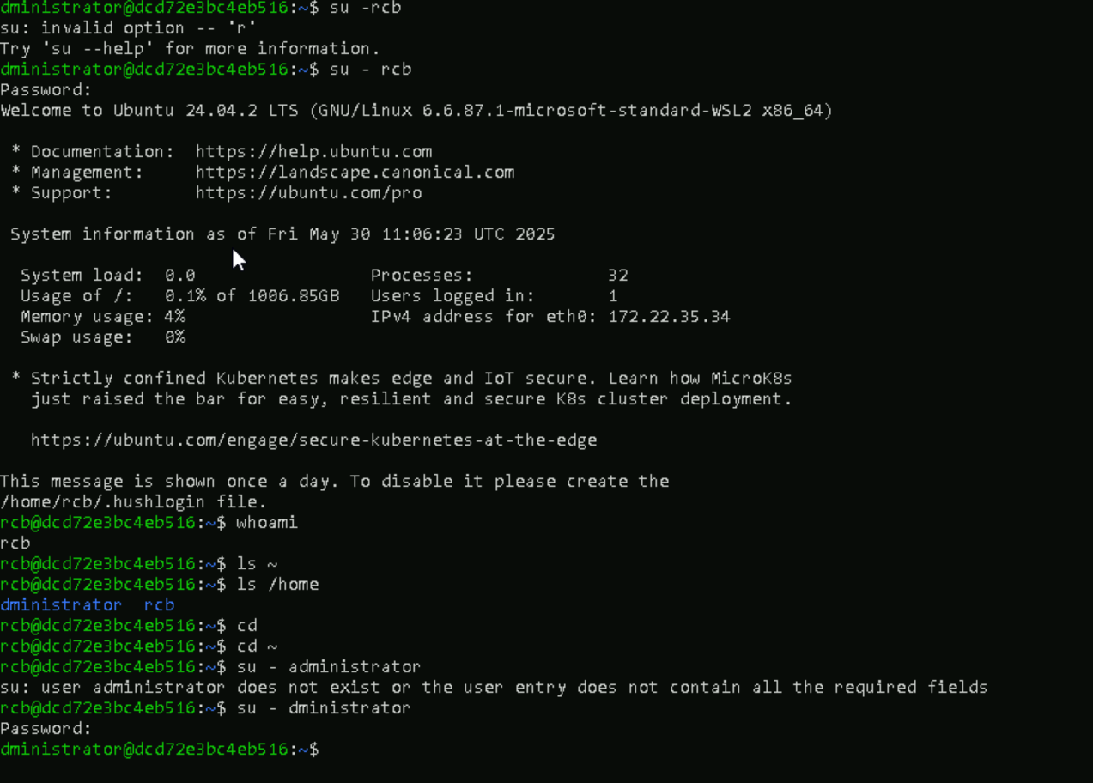

**TASK: 38 – chmods**

Chmod means change mode. Its used to change the permissions of files and directories.